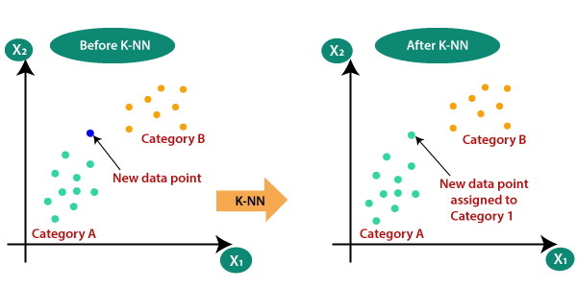

KNN BASED ALGORITHM
TRAINING AND TESTING
BY
HARSHRAJ PARMAR

OBJECTIVE

The purpose of the project is to learn in deep K-Nearest Neighbor(KNN) Algorithm for Machine Learning
- K-Nearest Neighbour is one of the simplest Machine Learning algorithms based on Supervised Learning technique.
- K-NN algorithm assumes the similarity between the new case/data and available cases and put the new case into the category that is most similar to the available categories.
- K-NN algorithm stores all the available data and classifies a new data point based on the similarity. This means when new data appears then it can be easily classified into a well suite category by using K- NN algorithm.
- K-NN algorithm can be used for Regression as well as for Classification but mostly it is used for the Classification problems.
- K-NN is a non-parametric algorithm, which means it does not make any assumption on underlying data.
- It is also called a lazy learner algorithm because it does not learn from the training set immediately instead it stores the dataset and at the time of classification, it performs an action on the dataset.
- KNN algorithm at the training phase just stores the dataset and when it gets new data, then it classifies that data into a category that is much similar to the new data.
- Example: Suppose, we have an image of a creature that looks similar to cat and dog, but we want to know either it is a cat or dog. So for this identification, we can use the KNN algorithm, as it works on a similarity measure. Our KNN model will find the similar features of the new data set to the cats and dogs images and based on the most similar features it will put it in either cat or dog category.
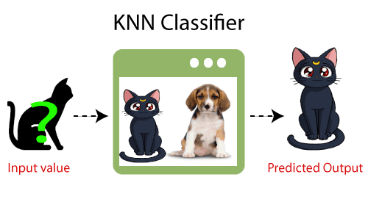

DATASET USED
- Banknote Dataset.

MODEL SELECTION

What Is Model Selection in Machine Learning?
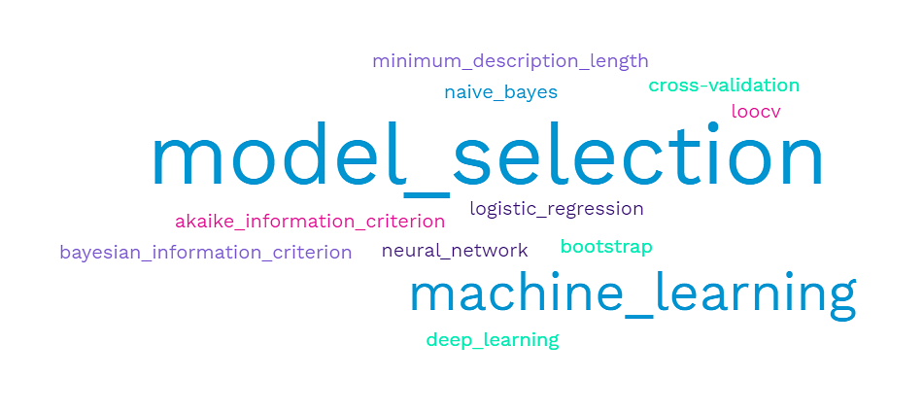
Model Selection is the process of choosing the best model among all the potential candidate models for a given problem. The aim of the model selection process is to select a machine learning algorithm that evaluates to perform well against all the different parameters. It is as essential as any other technique for the model performance improvement, such as data pre-processing that involves cleaning, transforming, and scaling the data before training, feature engineering to transform features and create new ones, hyperparameter tuning to find the best combination of parameters to optimize the model performance and many more.
Several model selection techniques involve comparing the model complexity, such as the quantity of the complex model parameters, and employing strategies like regularization to avoid overfitting. Model complexity selection is one of the most crucial steps in the ML model development lifecycle. It ensures that the final stabilized model is accurate and generalizable to the out-of-sample data.

why is Model Selection important in Machine Learning?
Model selection can have a significant impact on the performance and accuracy of the model. It is crucial to choose a suitable model for the problem and the dataset at hand, as it is an essential step for a variety of reasons.
- Rather than just selecting a model that performs well on the training data but performs poorly on the unseen data, selecting a well-suited model assists in making the final model chosen more accurate and generalizable to new data.
- Opting for a suitable model is as important as fine-tuning it to optimize its performance. It helps prevent overfitting, which happens on more complex models when the model fits the training dataset too closely.
- Model selection can assist in improving the final model's interpretability. Traditional machine learning models use simple, interpretable algorithms as compared to deep learning models. Comprehending and explaining the model's decisions is more straightforward when interpretable ml models are used.
- Selecting a model can save computing resources and time by eliminating candidate models that perform poorly early on and assists in improving the final performance.
To ensure optimal performance and accuracy, selecting the correct type of machine learning model for your specific project is essential. Let's take a look at some of the different kinds of models available.
Now that we understand the model selection in machine learning let's explore why it is such a critical aspect of a machine learning project.

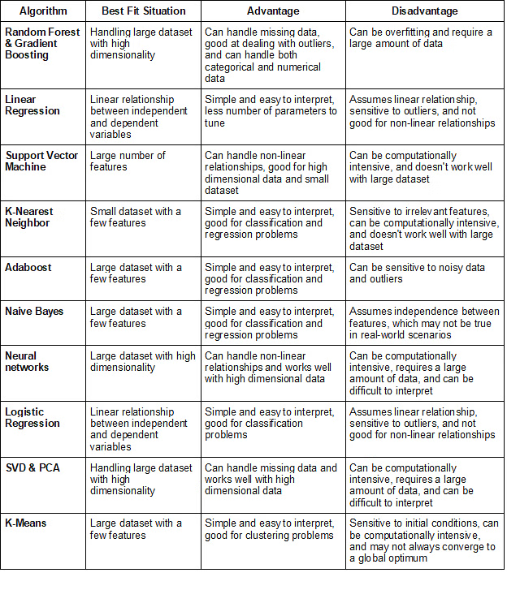

Looking at the Dataset and Problem statement Here I have Selected KNN MODEL for small numerical data set.

After Selecting The Model We will take a look at the Performance of the Model.

Performance Metrics

2.3 Performance metrics for classification
The most widely used technique for summarizing the performance of a classification algorithm is the Confusion Matrix. Figure 2 shows the confusion matrix for the case of binary classification with the following elements:
Fig. 2
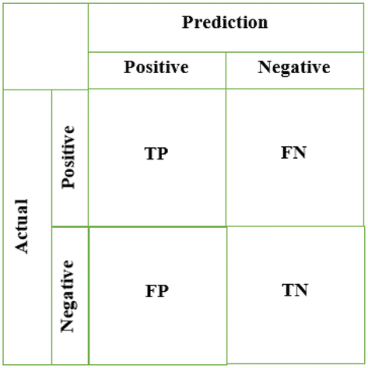
- True Positives (TP) is defined by the total number of accurate outputs when the actual class of the data object was True and the prediction was also the True value.

- True Negatives (TN) is defined by the total number of accurate outputs when the actual class of the data object was False and the predicted is also the False value.

- False Positives (FP) when the actual class of the data object was False and the output value was the True value

False Negatives (FN) when the actual class of the data object was True and the output value was the False value.

2.3.1 Metrics computed from a confusion matrix
A confusion matrix gives a useful information about how well the model does. However, its elements can be used to calculate many performance metrics to get even more information. Among the most popular are (see also Tables 1, 2):

- Accuracy is the most intuitive performance measure, and defined as the ratio of the number of correctly classified objects to the total number of objects evaluated.

- Precision it is simply a ratio of correctly predicted positive data objects to the total predicted positive data objects.

- Recall it is defined by the number of correct positive results divided by the total number of relevant samples (all samples that should have been identified as positive).

- F-score it can be defined as a weighted average of the precision and recall. An F-score is considered perfect when reaches its best value at 1, while the model is a total failure when it reaches the 0 value.

Challenges & Learnings
The KNN algorithm is one of the most popular data mining algorithms. It has been widely and successfully applied to data analysis applications across a variety of research topics in computer science. This paper illustrates that, despite its success, there remain many challenges in KNN classification, including K computation, nearest neighbor selection, nearest neighbor search and classification rules.

Moreover, the weakness of k-NN is that the selection of the k value requires special attention. Determining the k value and the computational complexity is a challenge in k-NN algorithm especially when the k value is even, and each class has the same number of votes .

he KNN model has a relatively low accuracy of only 0.288, This may be because the KNN model is too sensitive to the local structure of the data and is easily affected by noise and outliers when dealing with large-scale and high-dimensional data, resulting in poor prediction performance

The study results suggest need for future work: some weights and measures do not necessarily perform well because of the distribution or the quality of the data. Therefore in future work we will address optimisation of the weights selection based on this characteristic of the data representing the ability and quality of the training and testing sets.

